**PROJECT DESIGN PHASE-II**

**DATA FLOW DIAGRAM & USER STORIES**

|  |  |
| --- | --- |
| Date | 30 OCTOBER 2022 |
| Team ID | PNT2022TMID42671 |
| Project Name | IOT based Smart Crop Protection System for Agriculture |

DATA FLOW DIAGRAM:

If (moisture level) < (threshold value)

Sensors

Store data to IOT Cloud

Message to User

Buzzer/Sound

**Detect animals or birds**

Motor

(on/off ) 

Moisture Sensor

Temperature Sensor

Ultrasonic repellent Sensor

Mobile User App

IOT Cloud

Arduino Takes or gives instructions as per user Conditions

FLOW DIAGRAM SMART CROP PROTECTION IN IOT:

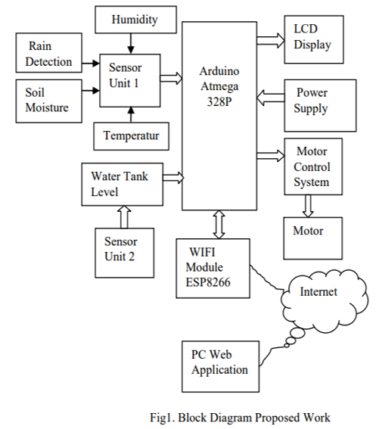

|  |  |  |  |  |  |  |
| --- | --- | --- | --- | --- | --- | --- |
| **User Type** | **Functional Requirement (Epic)** | **User Story Number** | **User Story / Task** | **Acceptance criteria** | **Priority** | **Release** |
| **Mobile user** | Registration | USN-1 | User can register | I can access | High | Sprint-1 |
| for the application | my account / |
| by entering email, | dashboard |
| password, and |  |
| confirming |  |
| password in mobile |  |
| app. |  |
| Mail | USN-2 | User will receive | I can receive | High | Sprint-1 |
| verification | confirmation email | confirmation |
| and | onceregistered for | and |
| confirmation | the application | verification |
|  |  | email & click |
|  |  | confirm and |
|  |  | verify. |
| Registration | USN-3 | User can register | I can register | Low | Sprint-2 |
| through | for the application | & access the |
| Facebook | through Facebook | dashboard |
|  |  | with Facebook |
|  |  | Login |
| Login | USN-4 | User can access the | I can login to | Medium | Sprint-1 |
| mobile application | my account |
| by entering email |  |
| and password |  |
| Dashboard | USN-5 | User can view the | I can view the | High | Sprint-1 |
| climatic condition | field data |
| USN-6 | User can view | I can view the | High | Sprint-1 |
| different type of | values of field |
| sensor value | shown by app |
| monitoring in the |  |
| field |  |
| USN-7 | User can able to | I can control | High | Sprint-2 |
| control and monitor | the field |
| the field manually | manually. |
| depending upon the |  |
| data report shown. |  |
| **Web user** | Functions are same as the mobile users through available web service. | | | | | |
| **Customer** | Technical | USN-1 | User can contact | I can able to | High | Sprint- 1 |
| **Care** | support team | and get the support | contact and |
| **Executive** |  | from technical | solve the |
|  |  | assistant when | issue. |

|  |  |  |  |  |  |  |
| --- | --- | --- | --- | --- | --- | --- |
| **User Type** | **Functional Requirement (Epic)** | **User Story Number** | **User Story / Task** | **Acceptance criteria** | **Priority** | **Release** |
|  |  |  | there is issue in IOT system. |  |  |  |
| Farmer welfare support care | USN-2 | User can able to get the help and information for increasing the yield and thereby giving solution to the problems. | I can able to get the info and solution to problem. | Medium | Sprint -2 |
| **Administrator** | Representative | USN-1 | User can get the support and information from respective authority | I can able get the info from administration | Medium | Sprint - 2 |
| Farmer Administration | USN-2 | User can act as part of organization after a period of time. They can manage the groups with some terms and conditions. | I can able to manage the organization activity | Medium | Sprint- 3 |
| **Customer queries** | Working | USN - 1 | User can able to get alert notification when threat is detect. | I can get intimation from the alert system | High | Sprint - 1 |
| USN-2 | User can able to turn on the motor pump / buzzer/Light system to overcome threats in field. | I can control the system to protect the cultivation | Medium | Sprint-2 |
| Availability | USN - 3 | User can able to get the report and monitor 24/7. | I can able to get the info at anytime | High | Sprint- 2 |
| Security | USN - 4 | User data is secured and end to end encrypted with password based system. | I can able to access the system through password only. | High | Sprint - 2 |

|  |  |  |  |  |  |  |
| --- | --- | --- | --- | --- | --- | --- |
| **User Type** | **Functional Requirement (Epic)** | **User Story Number** | **User Story / Task** | **Acceptance criteria** | **Priority** | **Release** |
| **Customer service** | Service assistance | USN - 1 | User can get service availability for the entire smart system periodically. | I can get the assistant for service. | Medium | Sprint -2 |
|  |  | USN-2 | User can get immediate reponse from the service assistant about functionality of the system. | I can get good response. | HIgh | Sprint -3 |